**DSP LAB VIVA QUESTIONS**

1. ***What Are The Elementary Discrete Time Signals?***

Unit sample sequence (unit impulse)

δ (n)= {1 n=0

0 Otherwise

Unit step signal

U (n) ={ 1 n>=0

0 Otherwise

Unit ramp signal

r(n)={n for n>=0

0 Otherwise

Exponential signal

x (n)=an where a is real

x(n)-Real signal

1. **What Is Fft?**

The Fast Fourier Transform is an algorithm used to compute the DFT. It makes use of the symmetry and periodicity properties of twiddle factor to effectively reduce the DFT computation time.It is based on the fundamental principle of decomposing the computation of DFT of a sequence of length N into successively smaller DFTs.

1. **How Many Multiplications And Additions Are Required To Compute N Point Dft Using Radix-2 Fft?**

The number of multiplications and additions required to compute N point DFT using radix-2 FFT are N log2 N and N/2 log2 N respectively.

1. **What is a Digital Signal Processor (DSP)?**Microprocessor specifically designed to perform fast DSP operations (e.g., Fast Fourier Transforms, inner products, Multiply & Accumulate)  
   •Good at arithmetic operations (multiplication/division)  
   •Mostly programmed with Assembly and C through Integrated Development Environment (IDE)
2. **Eqn for IDFT**

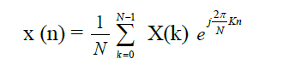

1. **Eqn for DFT**

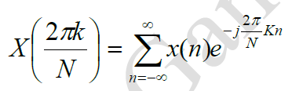

1. **Different types of radix 2 FFT**

Decimation in time and decimation in frequency

1. **Explain following functions in MATLAB**

1. clc🡪Clear command window and homes the cursors

2. clear all 🡪Removes all variables, globals, functions and MEX links.

3. close all 🡪 Closes all the open figure windows.

4. subplot(m,n,p)🡪Breaks the Figure window into an m-by-n matrix of small axes,

selects the p-th axes for the current plot, and returns the axis handle.

5. stem(x,y) 🡪 Plots the data sequence y at the values specified in x.

6. xlabel(‘text’) 🡪 Adds text beside the x-axis on the current axis.

7. ylabel(‘text’) 🡪Adds text beside the y-axis on the current axis.

1. **Explain Parseval’s relation.**

If G[k] denotes the N-point DFT of the length N sequence g[n], then: $\sum_{n=0}^{N-1}{{\left|g\left[n\right]\right|}^{2}}=\frac{1}{N}\sum_{k=0}^{N-1}{{\left|G\left[k\right]\right|}^{2}}$ 
 .

1. **What are some common applications for low-pass filters in DSP?**
   1. **Answer:** Low-pass filters are widely used in various DSP applications, including:
      1. **Anti-aliasing:** To prevent aliasing when sampling an analog signal. It removes high-frequency components that could be misinterpreted as lower-frequency components after sampling.
      2. **Audio Processing:** To remove high-frequency noise, such as hiss or static, from audio signals.
      3. **Image Processing:** To smooth images and reduce noise. It can also be used to blur edges.
2. What are the applications of DSP?

Speech coding & decoding Audio mixing & editing, speech encryption & decryption Image compression & decompression, Speech recognition, Image compression and processing.

1. What is the length of linearly convolved signals?

Length of linearly convolved signal is always equal to N = L + M - 1 where L is length of first signal and M is length of second signal.

1. Why linear convolution is important in DSP? The response or output of LTI discrete time system for any input x(n) is given by linear convolution of the input x(n) and the impulse response h(n) of the system. This means that if the impulse response of a system is known, then the response of the system for any input can be determined by convolution operation.
2. Why circular convolution is important in DSP?

The Discrete Fourier Transform (DFT) is used for the analysis and design of discrete time systems using digital computers. The DFT supports only circular convolution. Hence when DFT techniques are employed, the results of linear convolution are obtained only via circular convolution.

1. FFT is faster than DFT. Justify.

FFT produces fast results because calculations are reduced by decomposition technique. In FFT, N point DFT is decomposed into two N/2 point DFT’s, N/2 point DFT is decomposed into N/$ point DFT’s and so on.. Decomposition reduces calculations. FFT algorithms are implemented using parallel processing techniques. Because calculations are done in parallel, FFT produces fast computations.

1. Mention the importance of DFT

DFT is used for spectral analysis of signals using digital computer and to perform filtering operations on signals using digital computer.

1. What is convolution property of DFT?

Convolution in time domain corresponds to multiplication in frequency domain. If DFT{x[n]} = X[k] and DFT {h[n]} = H[k] Then DFT{x[n] * h[n]} = X[k] H[k]

1. List the differences between linear convolution and circular convolution.

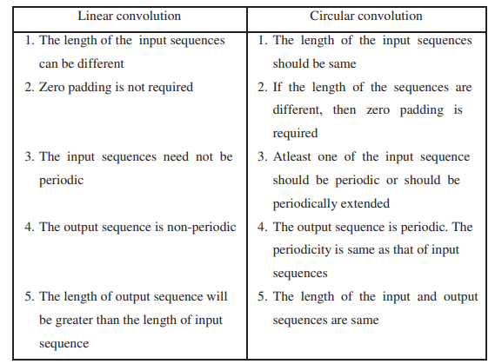

1. What is Zero padding? Why it is needed?

Appending zeros to a sequence in order to increase the size or length of the sequence is called zero padding. In circular convolution, when the two input sequences are of different size, then they are converted to equal size by zero padding.

1. Compare the overlap add and overlap save method of sectioned convolution

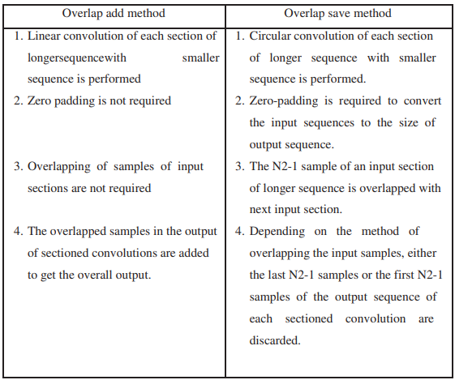

1. What is the difference between FIR and IIR filter?

IIR is infinite and used for applications where linear characteristics are not of concern.FIR filters are Finite IR filters which are required for linear-phase characteristics.3. IIR is better for lower-order tapping, whereas the FIR filter is used for higher-order tapping.FIR filters are preferred over IIR because they are more stable, and feedback is not involved.IIR filters are recursive and used as an alternate, whereas FIR filters have become too long and cause problems in various applications.

1. How to find output of FIR filter for long input sequence.

Overlap add and overlap save method

1. How to find Circular Convolution using FFT?

To find Circular Convolution of x[n] and h[n] using FFT, (i) Select N Let N = max(L,M) where L is the length of x[n] and M is length of h[n], (ii) Append x[n] by (N-L) zeros and Append h[n] by (N-M) zeros

1. Differentiate between General purpose MPU(Micro Processor Unit) and DSP Processor

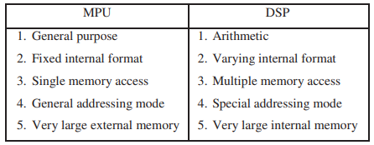

1. What is the role of window in the design of FIR filter? Name the few types of windows.

FIR filter is designed by truncating infinite samples of hd[n] by using window function. Examples of window function include, Hamming window,Bartlet Window, Hanning window, Blackman window etc.

1. MATLAB- MATrix LABoratory